TC-CMS-025
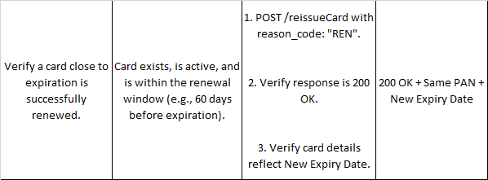
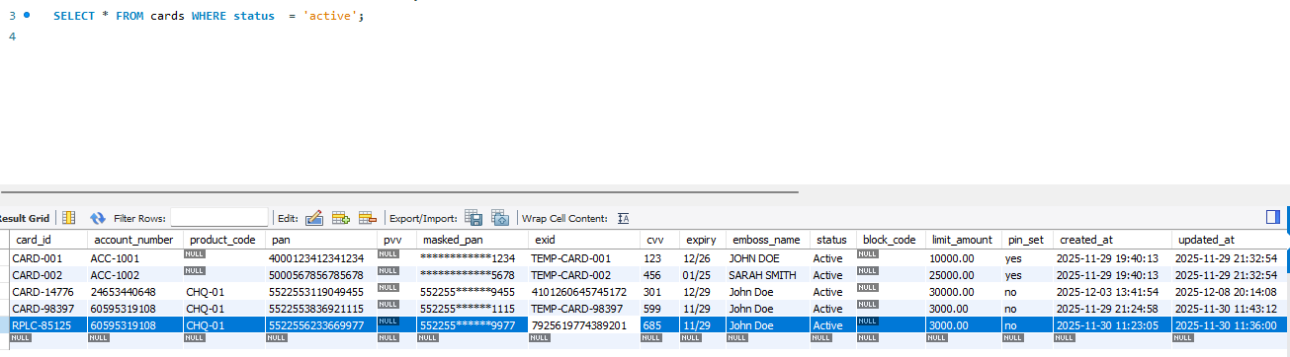
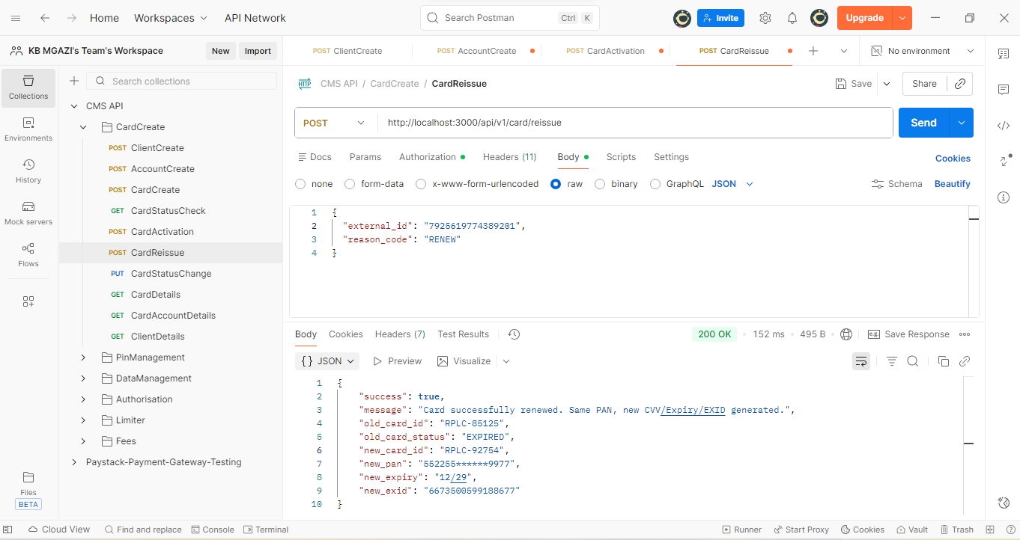
Request:
{
"external_id": "7925619774389201",
"reason_code": "RENEW"
}

Response:
{
"success": true,
"message": "Card successfully renewed. Same PAN, new CVV/Expiry/EXID generated.",
"old_card_id": "RPLC-85125",
"old_card_status": "EXPIRED",
"new_card_id": "RPLC-92754",
"new_pan": "552255******9977",
"new_expiry": "12/29",
"new_exid": "6673500599188677"
}

